“Diary Application with Autocomplete”

Overview:
This program is a console-based diary application which allows users to:
- Type diary entries (with real-time word suggestions via autocomplete)
- Auto-save unknown words to a dictionary file
- Save diary entries with the current date
- View all entries
- Search diary entries by date

Data Structures Used:

1.Trie (Prefix Tree)
Purpose:
Efficiently store words for quick prefix-based suggestions.
Structure:
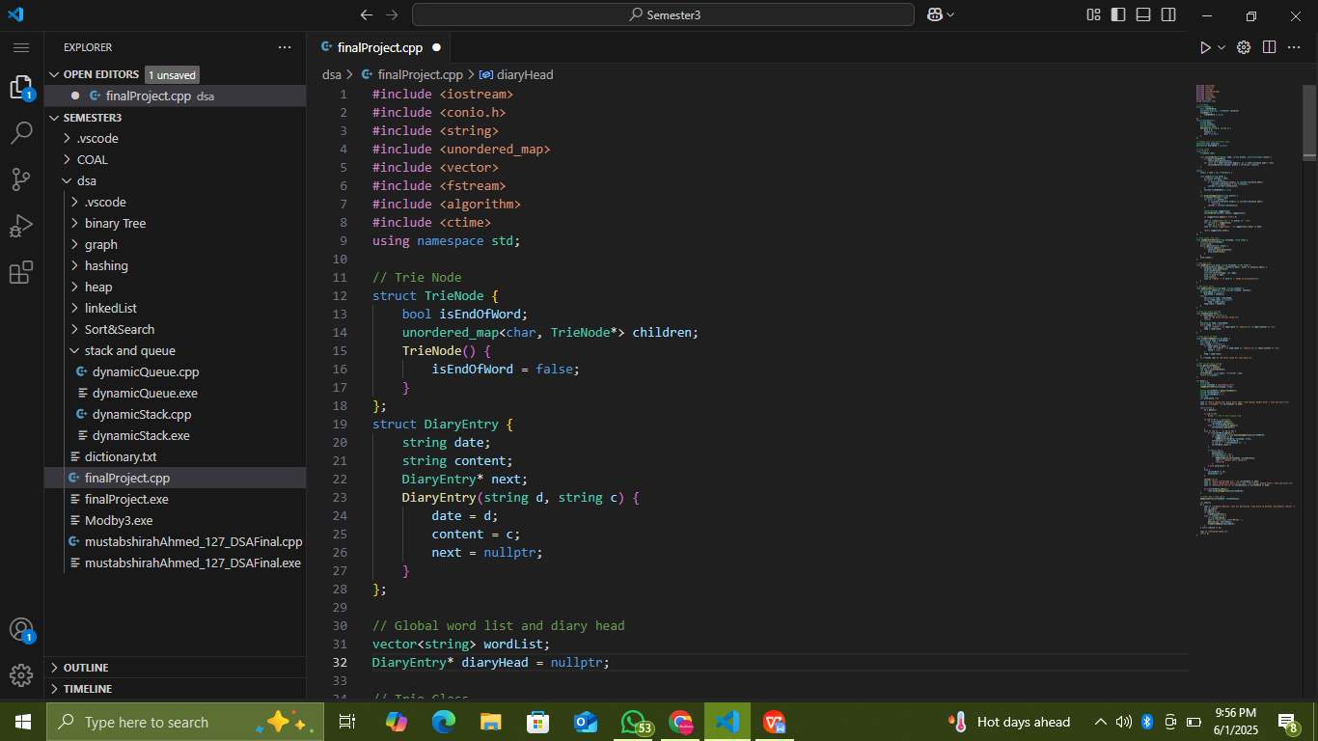
Features:
- Each character is a node.
- Children stored in an unordered_map<char, TrieNode*>.
- isEndOfWord marks the end of a valid word.
- Supports insertions and prefix suggestions.

2. Vector (wordList)
Purpose:
Maintain a list of all known dictionary words loaded from file.
Structure:


Features:
- Prevents duplicate word insertions.
- Used for quick lookup before adding new words.

3. Singly Linked List (DiaryEntry)
Purpose:
Store diary entries dynamically.
Structure:


Features:
- Each entry has a date, content, and a pointer to the next entry.
- Enables easy addition of new entries at the end.
- Supports traversing through all entries.
- Search entries by date.

Program Flow:

Program Initialization
- Load words from dictionary.txt into wordList and insert them into the trie.
- Get current date using: string getCurrentDate()
- Start capturing diary input character by character.

2.Diary Entry Input (with Autocomplete)
While typing:
- Each character added to currentWord.
- On pressing space or Enter:
- Autocomplete suggestions are displayed using trie.displaySuggestions().
- If no suggestion → add word to dictionary and trie.
- Append word to sentence.
- Reset currentWord.
Double Enter: saves the current entry and exits typing mode.
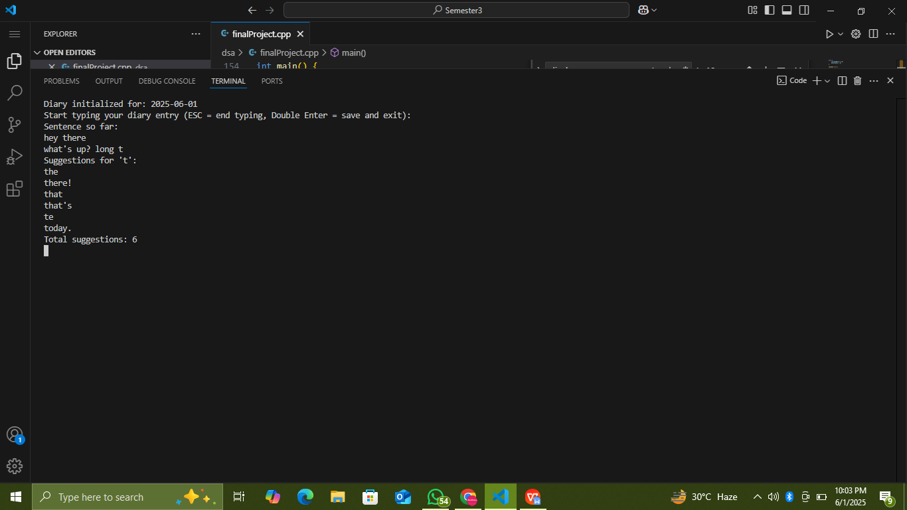

After Typing
- Save the diary entry : addDiaryEntry(currentDate, fullSentence);
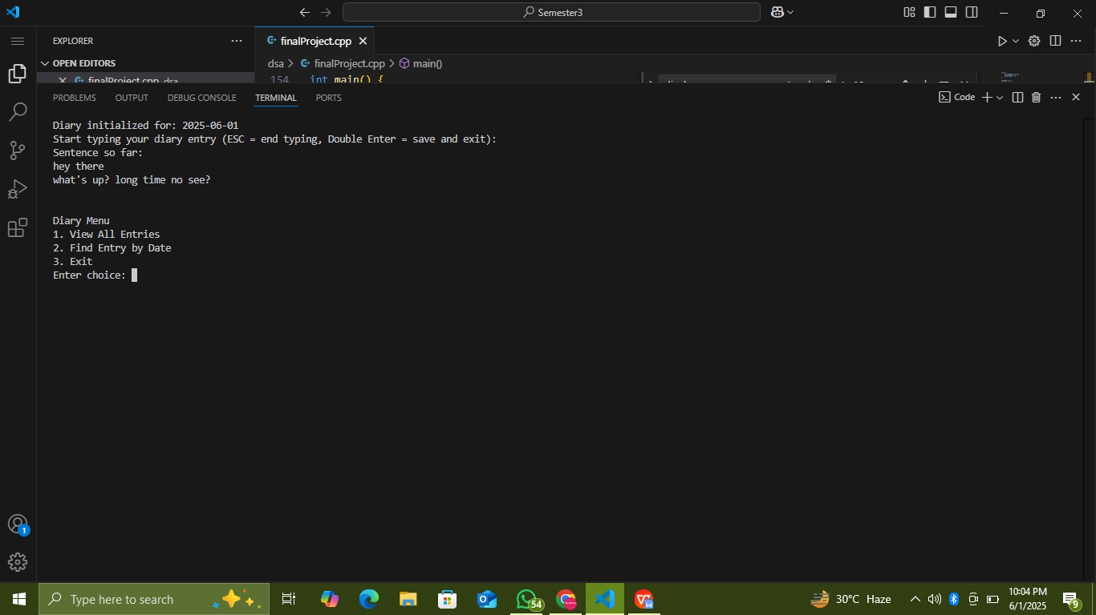
- Show main diary menu:

Key Features:
Feature | Description
Trie Autocomplete | Real-time word suggestions while typing diary entries.
Auto Word Save | New unknown words automatically added to the dictionary and trie.
Date Initialization | Diary initialized with the current system date.
Linked List Diary Storage | Entries stored as linked list nodes with date and content.
View All Entries | Displays all stored diary entries.
Search by Date | Allows searching for specific diary entries by date.

Advantages:
✅ Fast prefix-based word suggestion using trie.
✅ Dynamic storage of diary entries via linked list.
✅ Persistent word dictionary via file storage.
✅ Simple, clean user interaction in console.

Diagram — Example Trie Structure for Words

["help", "hello", "hell"]
root
└── 'h'
└── 'e'
└── 'l'
├── 'l' (isEndOfWord)
│ └── 'o' (isEndOfWord)
└── 'p' (isEndOfWord)

Time Complexity(Runtime)

Operation | Time Complexity (Big O) | Explanation
Insert word into Trie | O(L) | L is length of the word. Each character is inserted sequentially into trie nodes.
Display suggestions (Autocomplete) | O(P + S × A) | P is length of prefix. S is number of suggestions, A is average word length. Collect words using DFS.
Load words from file into Trie | O(N × L) | N is number of words in file, L average word length. Each word is inserted one by one.
Add word to wordList (vector) | O(1) (amortized) for push_back, O(N) for find() | push_back is O(1), but find to check for duplicates is linear.
Add diary entry (linked list) | O(E) | E is number of diary entries (traversing to end of list for insertion).
View all diary entries | O(E) | Traversing linked list to print entries.
Find entry by date | O(E × D) | E is number of entries, D is average length of date strings (constant in this case).
Get current date | O(1) | Uses system time, constant time operation.
Typing loop per character (display suggestions) | O(P + S × A) per word (see above) | Because for each completed word (on space/Enter) it calls displaySuggestions.

Space Complexity (Memory)
Data Structure | Space Complexity | Explanation
Trie | O(T × L) | T is total number of unique characters inserted, L is average word length. Each node has a map of possible next characters.
wordList (vector) | O(N × L) | N is number of words, L is average length.
Diary entries (linked list) | O(E × C) | E is number of entries, C is average content length.
Suggestions (vector inside displaySuggestions) | O(S × A) | S is number of suggestions, A is average word length. Temporarily created per suggestion call.

Total (Approximate Combined)
Worst-case Time per Entry: O(E + P + S × A)
E for diary traversal
P + S × A for autocomplete suggestions
Worst-case Space (Memory Used Together):
O(T × L + N × L + E × C)

Conclusion:
This program is a simple yet functional diary application integrating:
Data structures like trie, vector, linked list.
File handling for persistent dictionary.
Dynamic input processing with real-time suggestions
Date-wise diary management
It’s an excellent practical example of applying data structures to a real-world inspired application.

“Diary Application with Autocomplete”
Project and Report by: MUSTABSHIRAH AHMED
Roll.No: (B23110006127)

Data Structure And Algorithm
Course Incharge: Ms. Maryam Feroze

